Rules and Security Advice
-Spanish Section of the Union Registry-

Pursuant to the provisions of the Spanish Section of the Union Registry account opening and maintenance application form, users of the Spanish Section of the Union Registry must comply with these security rules and advice included in this document.

This document outlines a series of security guidelines which users accessing or carrying out any actions in the Spanish Section of the Union Registry should adhere to so as to guarantee maximum security and avoid identity theft. Users should be aware that fraudulent emails and websites can be very sophisticated and appear genuine.

The list below identifies some guidelines and security measures which users of the Spanish
Section of the Union Registry should adhere to:

➢ To connect to the Union Registry, users must use a workstation provided by their organization and/or their own device if authorized by their organization’s security policy.

➢ Users should have, at least, an antivirus software on the device used to connect to the Spanish Section of the Union Registry and ensure that this is kept up-to-date. However, we strongly recommend using two different antivirus programs (from two different vendors) run in parallel.

➢ Users should ensure that the antivirus installed on the device used to connect to the Spanish Section of the Union Registry automatically for malicious virus/spyware check must be configured so that it is performed automatically at least every two weeks using up to date antivirus and anti-malware software.

➢ Users should have, at the very least, a firewall installed on the device used to connect to the
Spanish Section of the Union Registry and ensure that this is kept up-to-date1.

➢ Users should ensure the operating system and any other software installed on the device used to connect to the Spanish Section of the Union Registry is up-to-date with the latest version and includes updated security applications.

➢ Users should draw up a list of authorized software installed on the device used to connect to the Spanish Section of the Union Registry and ensure that no other software is installed. Any unauthorized software should be deleted. These checks can be carried out with the assistance of qualified IT technicians entrusted with maintaining and monitoring IT equipment.

➢ Users should ensure that all device access to the Spanish Section of the Union Registry is analyzed by qualified IT technicians entrusted with maintaining and monitoring IT equipment to detect any unauthorized access. Any unauthorized access shall be investigated.

1 A firewall is a system designed to guarantee the security for all communications through Internet. This firewall block the access to or from a private network,

➢ Users should only connect to the Spanish Section of the Union Registry using a secure Internet access. This connection should include a firewall, an intrusion detection system, an antivirus and mechanisms to restrict access to insecure websites.

➢ Users should not share the device used to connect to the Spanish Section of the Union Registry with other users.

➢ Users should ignore and not open any emails with links to the Spanish Section of the Union Registry website In this regard, IBERCLEAR will never send emails with links to the Spanish Section of the Union Registry website.

➢ Users should ignore any emails requesting usernames, passwords or SMS TAN (transaction authentication number). Cases of phishing have increased in recent years2. IBERCLEAR will never ask for usernames, passwords or SMS TAN (transaction authentication number) used to connect to the Spanish Section of the Union Registry, nor shall request details of any software installed. All emails sent by IBERCLEAR contain this address correo.titulares.renade@renade.es, auditoria.renade@grupobme.es; DesarrolloNR.renade@grupobme.es

➢ Users should not open any email attachments which are not from the Union Registry (CLIMA- EU-ETS-REGISTRY-PROD@ec.europa.eu) until the origin of the email has been carefully checked.

➢ Users should not open any attachments with the following extensions: .com, .bat, .vbs, .wsh, or
.exe.

➢ Users should immediately contact IBERCLEAR and wait for advice if they are unsure as to the origin, content, etc. of any emails received (spelling mistakes could be an indication that the email is fraudulent), or if they have any other suspicions. In this regard, users of the Spanish Section of the Union Registry shall always be informed of any significant events regarding the Union Registry, either by emails from IBERCLEAR or via announcements on the Spanish Section of the Union Registry website.

➢ Users Computers must have a screensaver configured, so that, after no more than 15 minutes of inactivity the workstation must be locked down. A policy must also apply of not leaving a computer unattended without applying a screensaver – this ensures that a screensaver is always applied when a user is not at their desk.

➢ Users should not configure the auto log-in option on the device used to connect to the Spanish Section of the Union Registry. Instead they should enter their username and password each time. The Internet browser should therefore be configured not to remember the username and password. Browser must be configured so that credentials cannot be stored by the browser and all temporary stored navigation information (such as historic, passwords, cookies) are automatically deleted when closing the browser.

➢ Users should avoid starting up the device with CDs, DVDs or USBs and configure the BIOS
accordingly. Users should not be able to access the BIOS on the device used to connect to the

2 About phishing
Phishing is the attempt to acquire sensitive information such as usernames and passwords by masquerading as a trustworthy entity in an electronic communication.

How phisher works
Attacks usually take the form of misleading emails supposedly sent by the company in question. These emails contain links which redirect users to a fake website whose look and feel are almost identical to the legitimate one. Phishers pose as trustworthy representatives or companies in apparently official looking emails, some forms of instant messaging service or even by phone. The damages caused by phishing can range from email accounts being blocked to important financial losses.

Spanish Section of the Union Registry. The BIOS should be protected with a password which is different to the one used to access the Spanish Section of the Union Registry.

➢ Users should ensure that the device used to connect to the Spanish Section of the Union Registry is configured to prevent other devices, such as printers, from being installed. It should also be configured to prevent runtime servers (e.g. http(s), ftp, etc.) or file exchange programs (e.g. BitTorrent) being used.

➢ Only secure USB drives should be used on the device used to connect to the Spanish Section of the Union Registry. In any case, the device should have a system which detects and registers the connection of a USB drive.

➢ Users should avoid any unauthorized use of the mobile phone used to connect to the Spanish
Section of the Union Registry.

➢ Users should not use the mobile phone which receives SMS TAN (transaction authentication number) to be able to connect to the Spanish Section of the Union Registry to carry out any online transactions.

➢ Users should not reveal their username, password or SMS TAN (transaction authentication number) to anyone, including other account holders. These are strictly personal and any transaction carried out in the Spanish Section of the Union Registry using these details shall be considered to be the responsibility of the owner of the username, password or SMS TAN (transaction authentication number). Therefore, users are responsible for all activity carried out with their username, password or SMS TAN (transaction authentication number) and should immediately notify IBERCLEAR if their account in the Spanish Section of the Union Registry has been accessed by an unauthorized third party. Users shall be held responsible for any damages arising from the failure to notify such information. Users should also notify IBERCLEAR immediately if a username, password or SMS TAN (Transaction Authentication Number) is lost or stolen. Users shall be held responsible for any damages arising from the failure to notify such information.

➢ Users should choose an alphanumeric password using upper and lower case letters. This should be changed regularly. Please note that unused usernames and passwords shall be deactivated after six months.

➢ Users should always remember to close the session and log off from the Spanish Section of the
Union Registry to avoid unauthorized access.

➢ Users should notify IBERCLEAR of any changes to the email address associated to the account open in the Spanish Section of the Union Registry. IBERCLEAR shall always verify that the originating address of the email received coincides with the one held on file.

➢ Users shall connect to the Spanish Section of the Union Registry website by writing the address directly in the search box. If this is procedure is not followed, users should always verify that they are typing in the data on a secure page. To do so:

check that the URL begins with "https": (safe server), and not “http:”

Check the security certificates of the page accessed. To do this,

“Microsoft Edge”,

Once users access to the Spanish Section of the Union Registry website click on the lock icon (this should be locked) which appears when a secure site is accessed. The lock will appear on the right hand side of the address bar while:

Click on the lock icon → “Ver certificados”
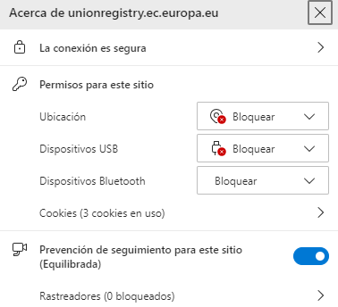

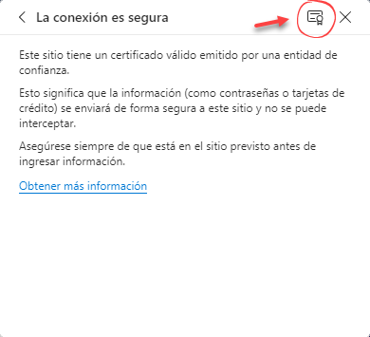
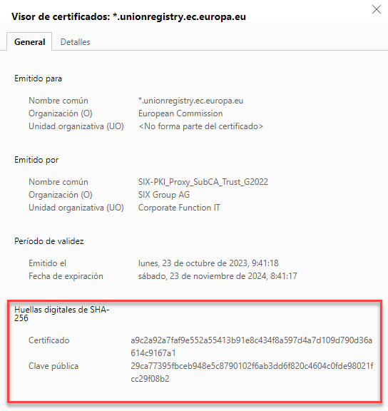

“Chrome”,

Once users access to the Spanish Section of the Union Registry website click on F12 or on the right hand side of the address bar while:

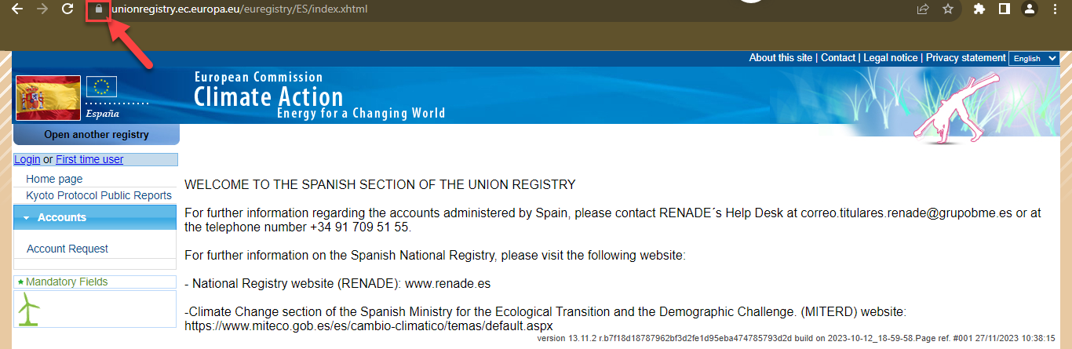

Click on “Mas herramientas → Herramientas para desarrolladores”

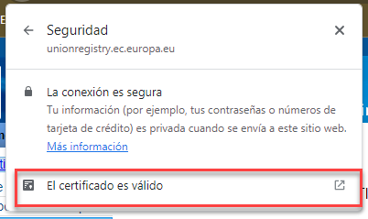
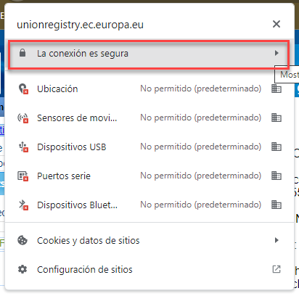

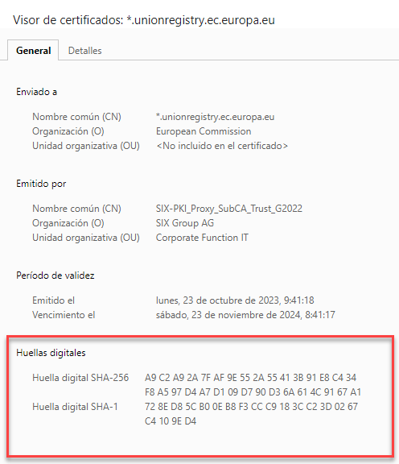

”:

IBERCLEAR will never contact you to request your username or password or SMS TAN (transaction authentication number) either by phone, email, fax, etc. Should you receive a message requesting this information or be wary of the authenticity of any email or website which purports to be from or belong to IBERCLEAR, please do not provide any information and contact IBERCLEAR immediately on 91 709 51 55.

At the end, a list of security advices that should be observed by the users of the Spanish Section of the Union Registry:

➢ Users should have installed at least two antivirus software installed from different providers on the device used to connect to the Spanish Section of the Union Registry.

➢ Users shall connect to the Spanish Section of the Union Registry website by writing the address directly in the search box.

➢ Users shall ignore repeat emails. If you receive two or more emails from different sources but with the same subject, your device may have a virus.

➢ Users should not use public devices (cybercafés, libraries, universities, etc.) to connect to the
Spanish Section of the Union Registry.

On behalf of and representing the Account Holder3 [Name of the Account Holder], (hereinafter, the “Account Holder”), I hereby state that I have read and understood the security rules and advices explained in this document and I forced myself to know these security rules and to communicate and enforce by all users who make any kind of action in the Spanish Section of the Union Registry in relation to the account opened in that Area by the Account Holder. I shall also notify these security advices to any users who connect to the Spanish Section of the Union Registry in relation to the account opened in that Area by the Account Holder.

[Name and surname of the Legal Representative]

In [place], on [click to write a date]

3 Name of the Account Holder of the account held in the Spanish Section of the Union Registry

